**SALESFORCE_SAPI_TASK_AFTER_ADDING_NEW_ENDPOINTS**

To upgrade the Previous salesforce SAPI which was built only for getting the details of organizations in Salesforce.

Three more endpoints were added which includes

POST /organizations  
GET /jobs/{id}/status

GET /jobs/{id}/failed-records

The Changes made in RAML Specs are

1) Adding Error Response Traits

2) Added Security Scheme

3) Added Three Endpoints

4) Added Datatypes files

5)Updated the common-fragments-library

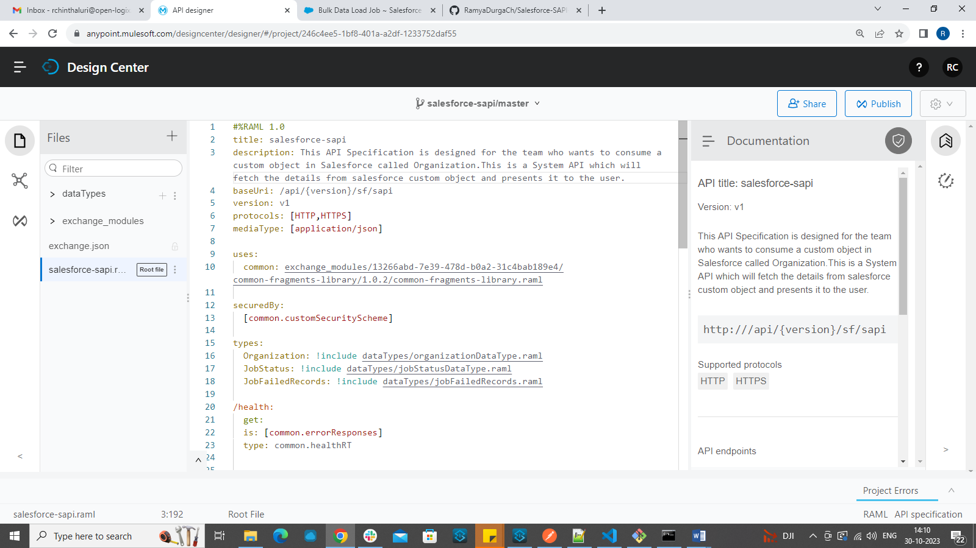

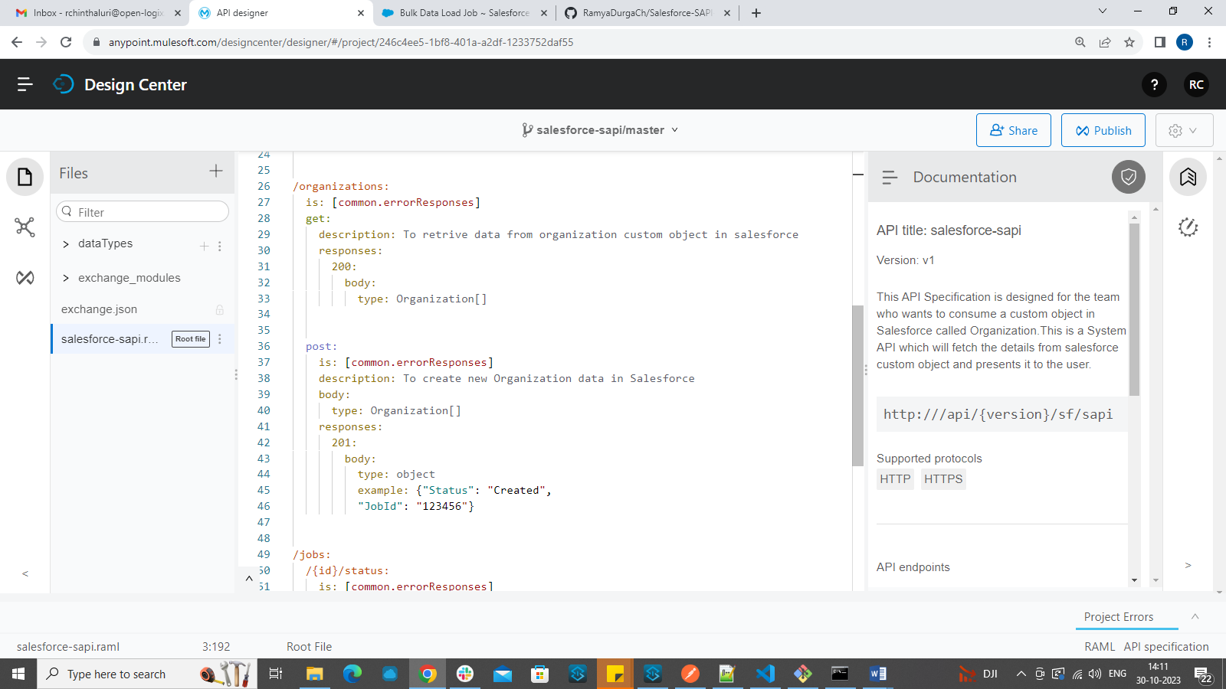

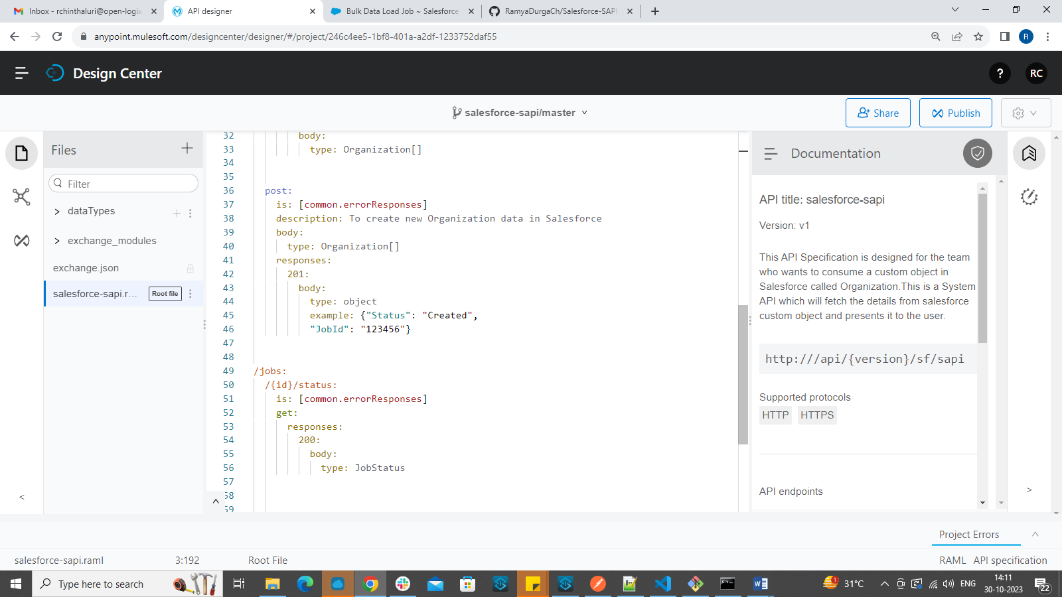

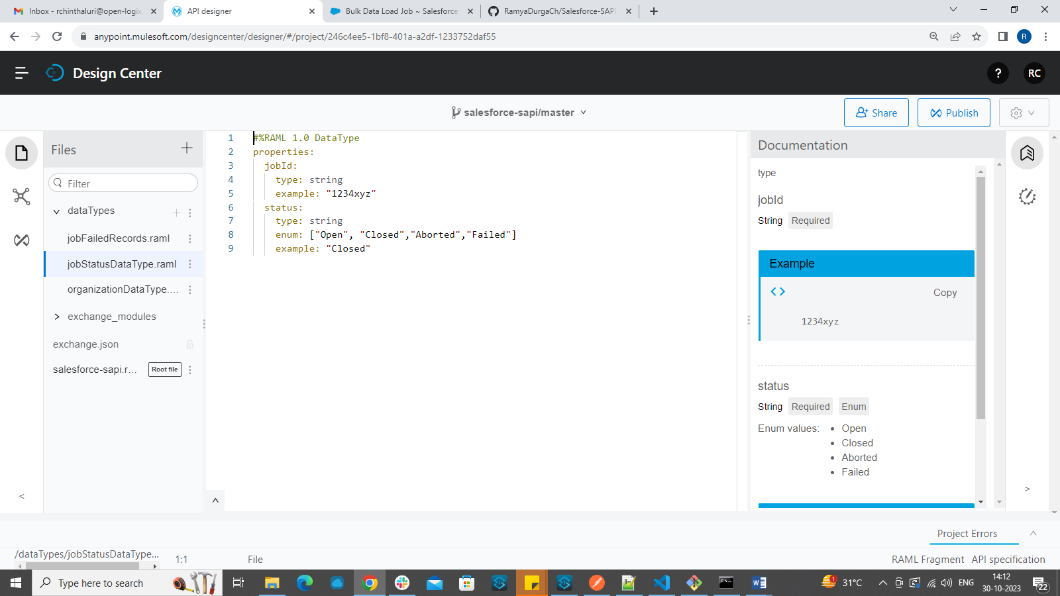

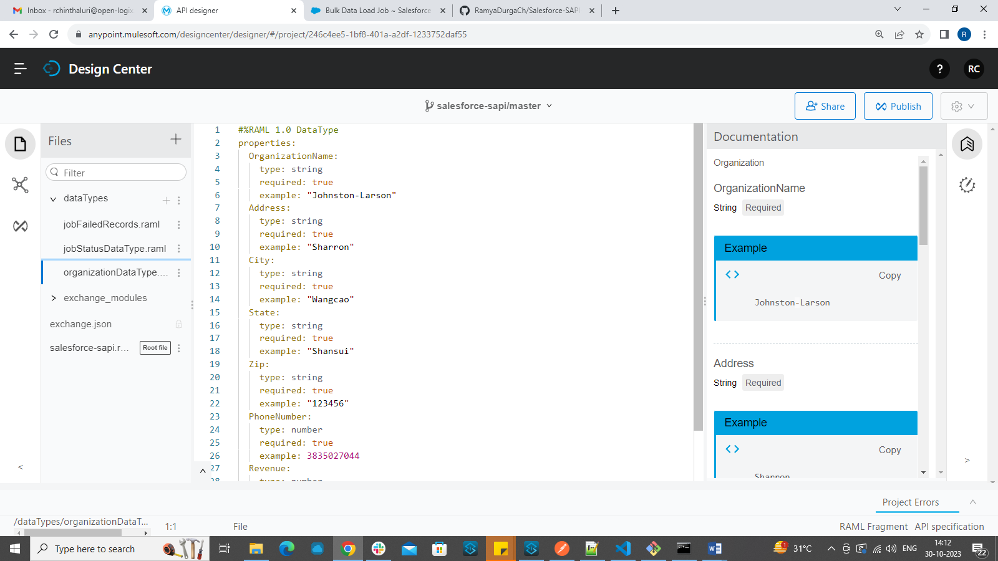

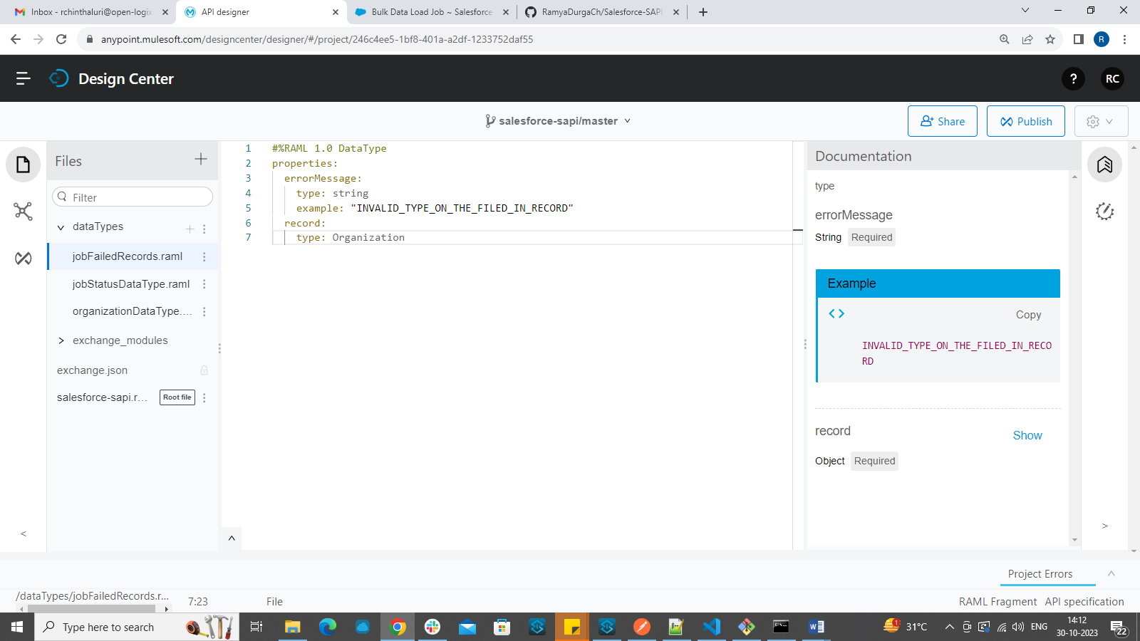

Published to exchange:

https://anypoint.mulesoft.com/exchange/13266abd-7e39-478d-b0a2-31c4bab189e4/salesforce-sapi/minor/1.0/

**IMPLEMENTATION:**

**Created separate xml file for each endpoint implementation including health endpoint:**

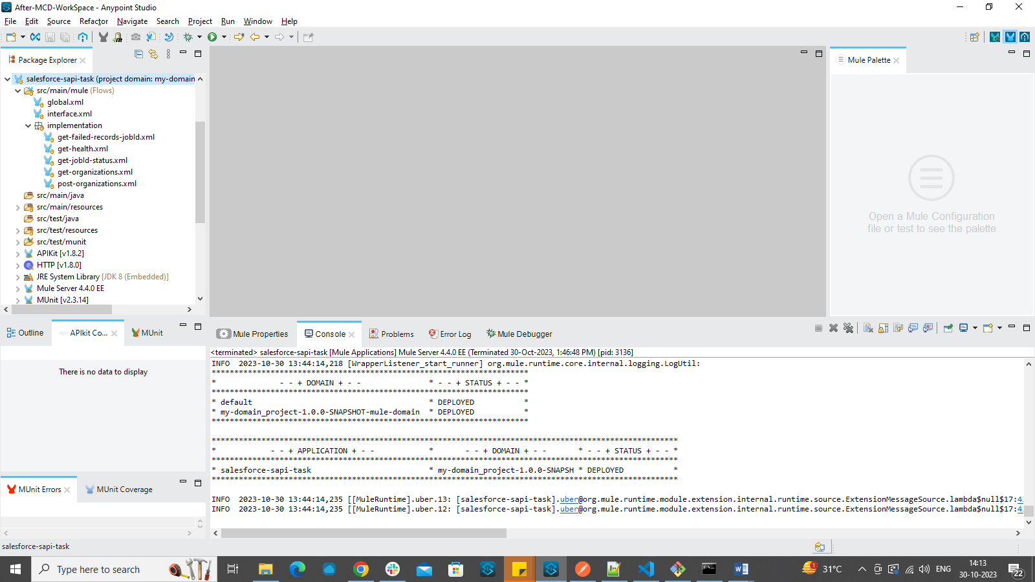

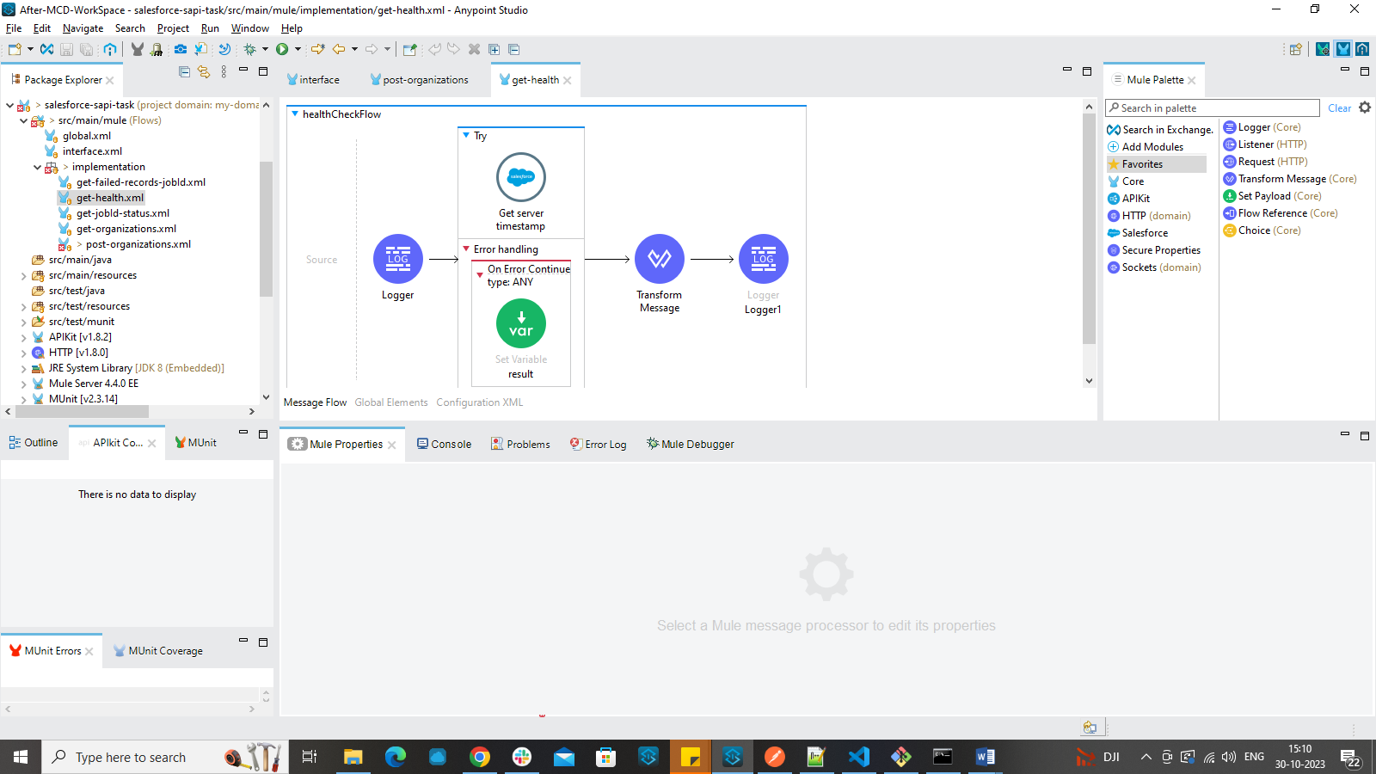

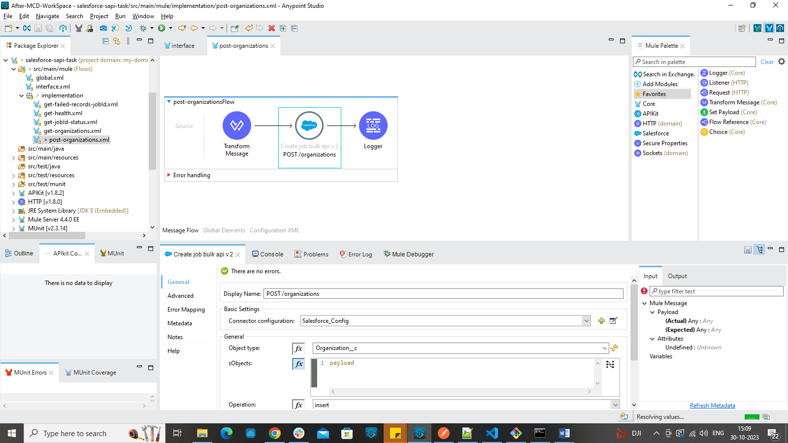

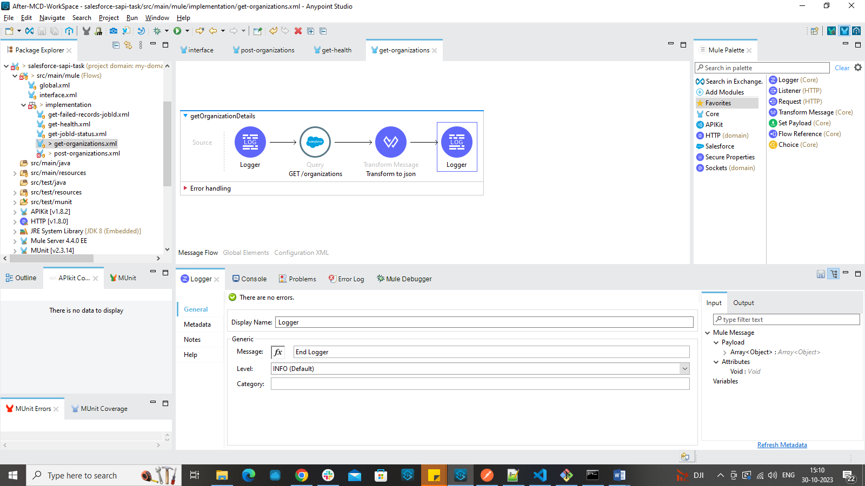

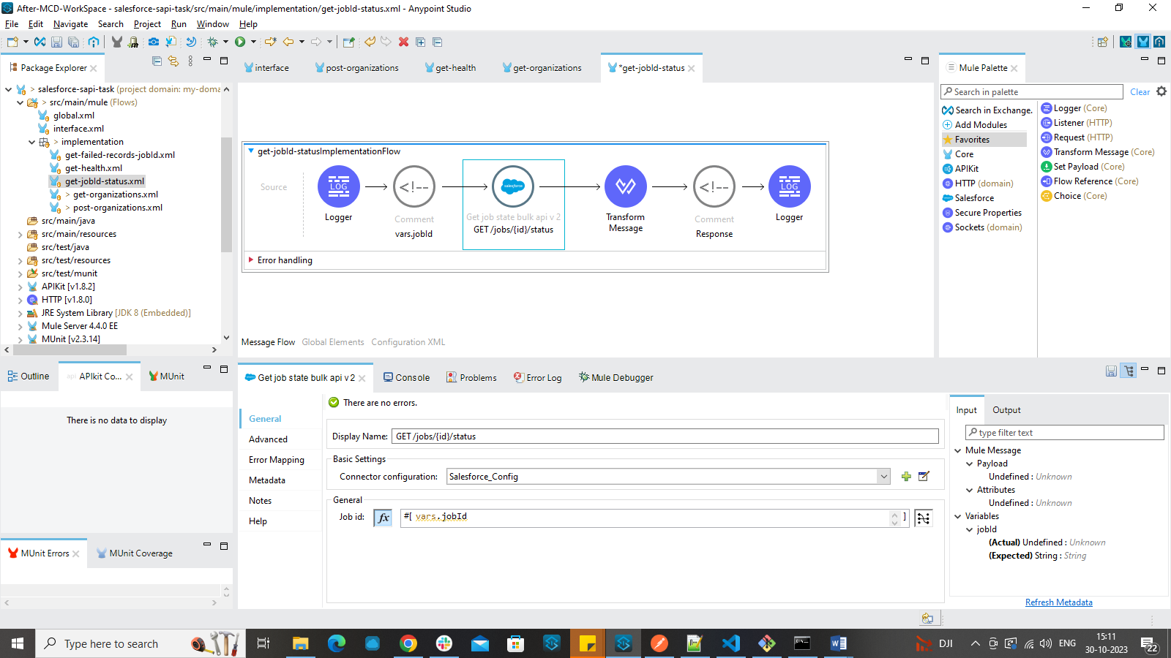

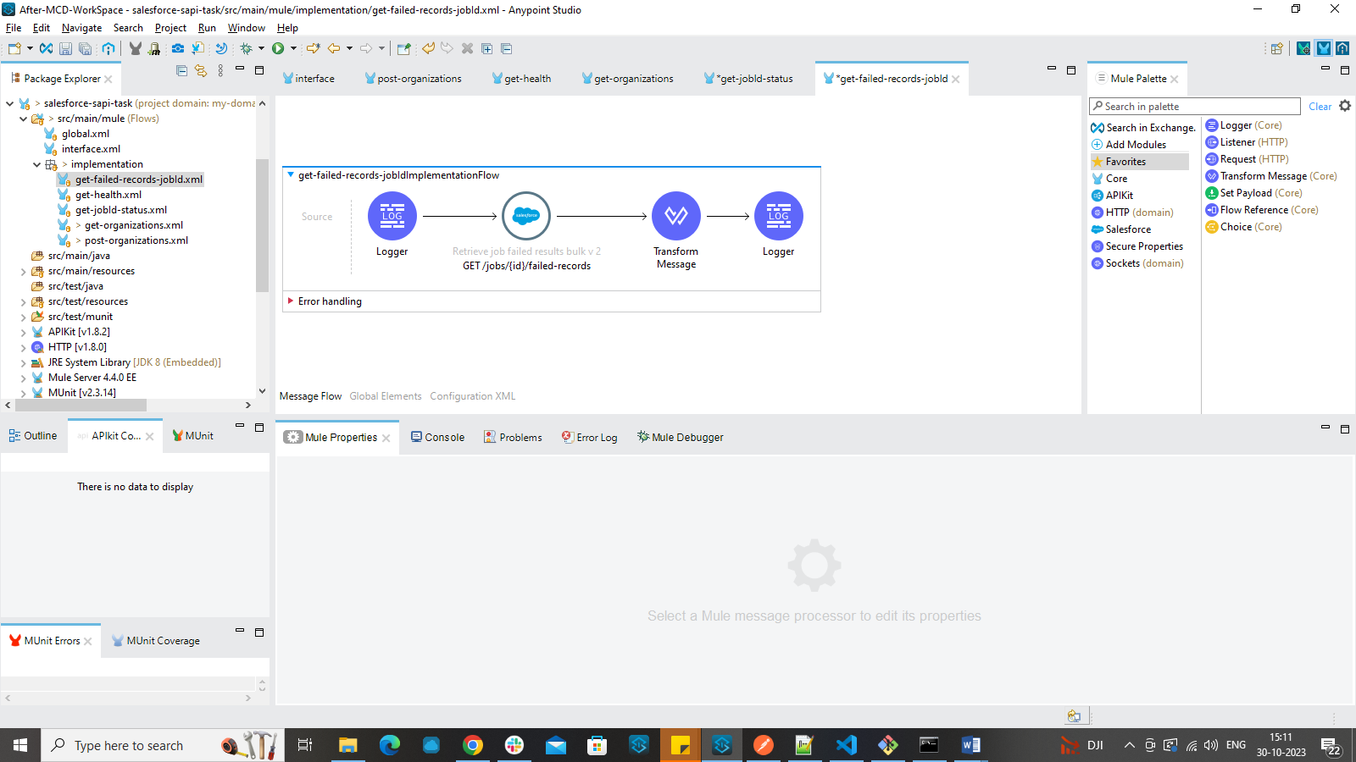

**OUTPUTS:**

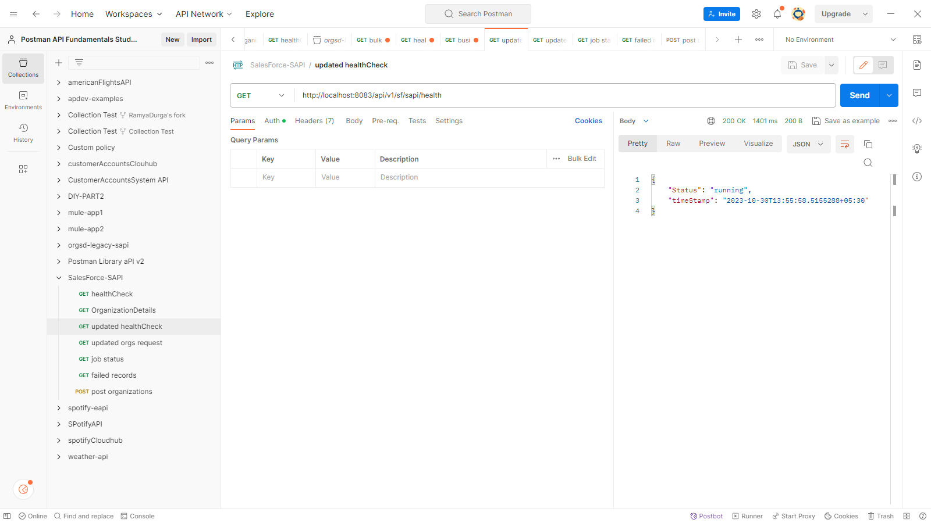

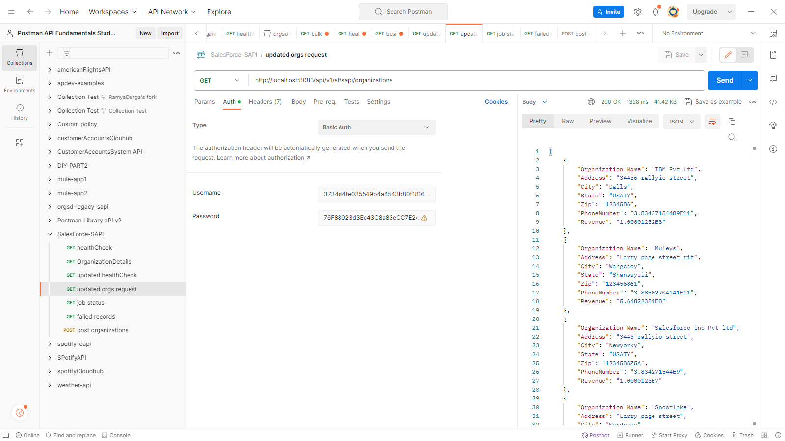

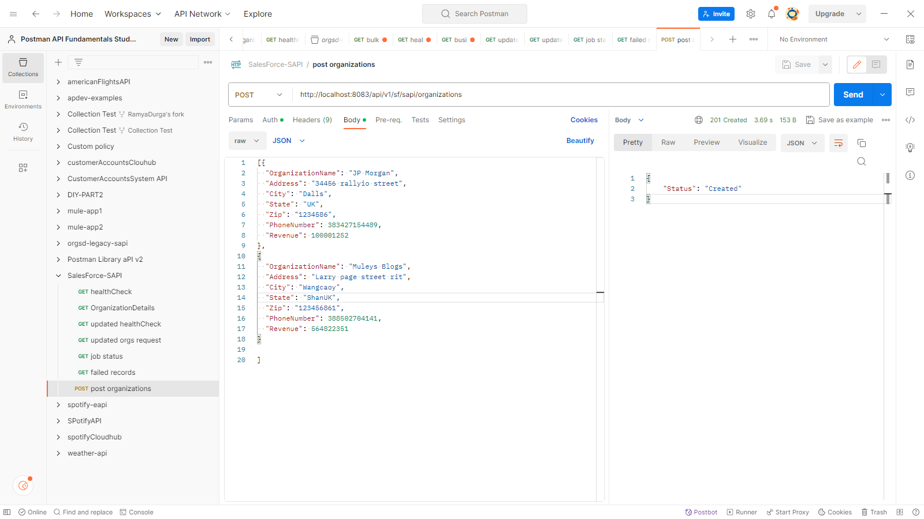

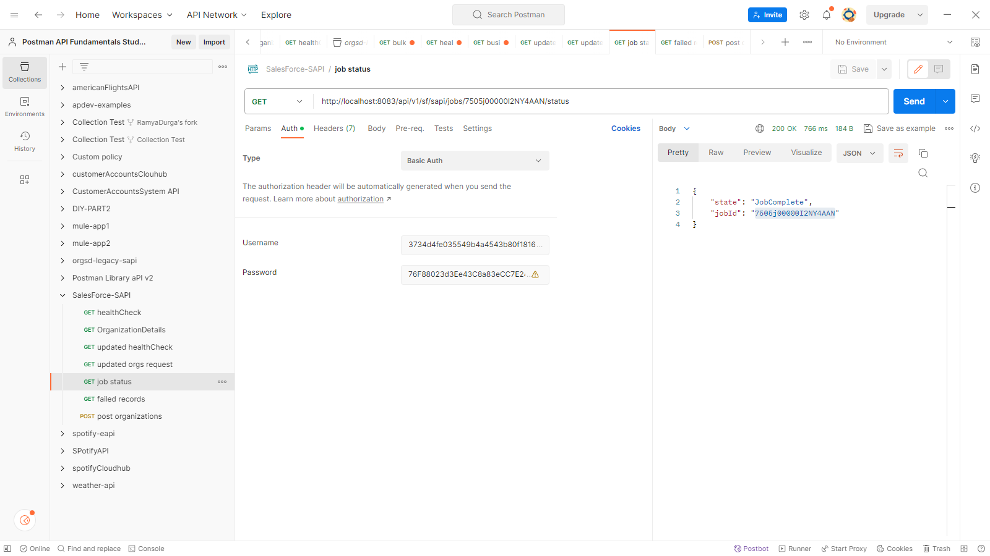

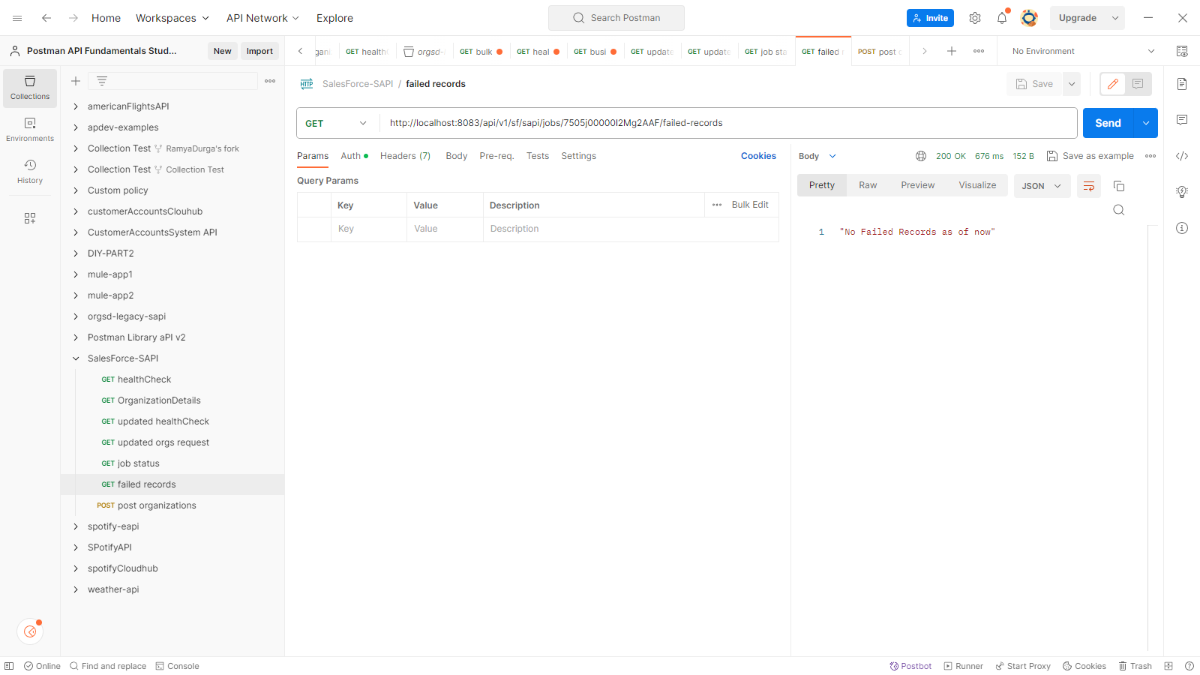

**Domain Project:**

